中興大學機械工程學系 研究所特殊情形人工加選處理
說明: 課務組規定之研究所特殊情形人工加選期間處理，115學年上學期 (9/17 8:00am -9/24 5:00pm)。 課務組發選課清單至系辦，系辦將選課清單置放教授休息室各老師之信箱(預計9/17下午5點)， 請指導教師確認後之選課清單轉交給研究生確實核對。

- 若須異動，請研究生向指導教授領選課清單，選課清單先註明退選或加選(填課號及課名)如下方所示，再請授課教師及指導教授簽章同意後，將選課清單一、二聯送課務組彙辨，逾期無法受理。
- 課程無異動者，選課清單由指導教授及研究生自行留存不須交回。
- 碩專未有指導教授者，請洽晚上助理 領取確認。
選課清單人工加選或退選範本參考如下:
二聯註記好加選或退選，請授課老師簽章，再經指導教授簽章，於期限內送課務組辦理。
國立中興大學115學年度第1學期學生選課清單
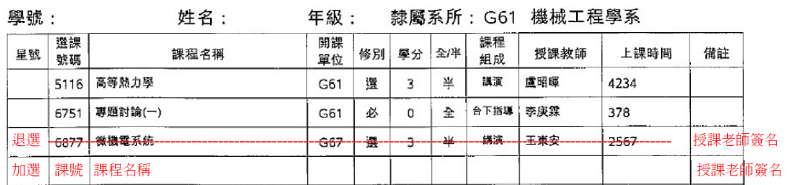
指導教授簽章：
國立中興大學115學年度第1學期學生選課清單
指導教授簽章：
National Chung Hsing University – Department of Mechanical Engineering
Graduate Program Manual Course Add/Drop Processing for Special Circumstances
Description:
Manual course add/drop requests for graduate students during the special period designated by the Curriculum Section will be handled as follows for the First Semester of Academic Year 115 (September 17, 8:00 AM – September 24, 5:00 PM.). The Curriculum Section will send course selection lists to the department office, which will place them in each professor’s mailbox in the faculty lounge (scheduled for September 17 at 5:00 PM). Advisors are asked to review the lists and forward them to their graduate students for verification.
- If changes are required, graduate students should collect their course selection list from their advisor. Indicate any course drops or additions (include course code and course title) on the list as shown below. After obtaining approval signatures from both the course instructor and the advisor, submit copies 1 and 2 of the course selection list to the Curriculum Section for processing. Late submissions will not be accepted.
- If there are no changes, the course selection list may be retained by the advisor and student; submission is not necessary.
- Master’s Professional Program students without an assigned advisor should contact Assistant Yen-Ting Chi in the evening to collect and confirm their course selection list.
Course Selection List and Manual Add/Drop Form – Template Reference
Please mark Add or Drop on both copies of the form, obtain the course instructor’s signature, and then have your advisor sign it. Submit the completed form to the Course Affairs Divi

NCHU 2026 Fall Semester - Course Selection List
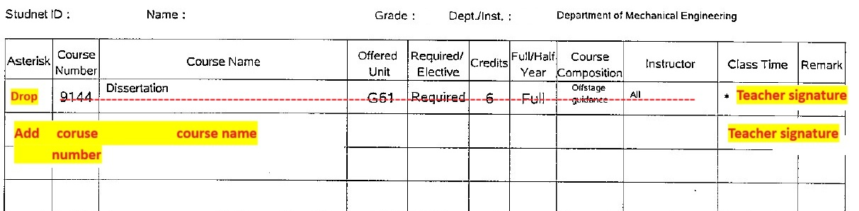
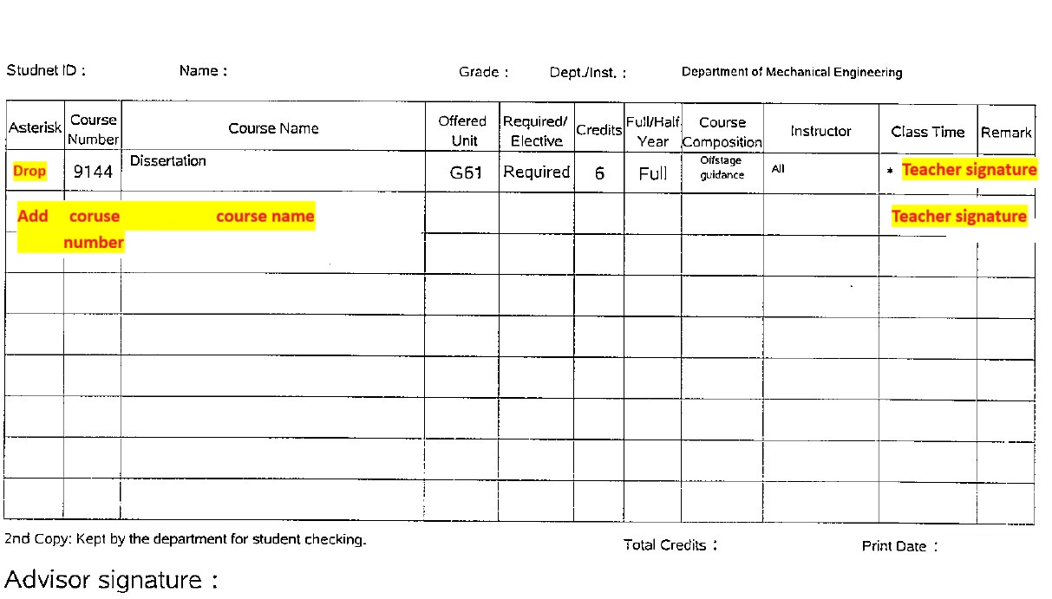
Advisor signature：
NCHU 2026 Fall Semester - Course Selection List
Advisor signature：

